Omni Youth Programs  Omni Youth Programs is a non – profit agency dedicated to preventing teen alcohol and marijuana by strengthening families and developing youth leaders in Sacramento County. We have offered free youth, parent and community services in Sacramento County since 1979.  “The Other Side of Cannabis” Free Video Screening: The Award-Winning film explains the negative effects of marijuana on our youth and will help you to understand today’s marijuana through interviews with researchers, other professionals, and individuals whose lives were impacted by this drug.  Certification in 4 Different Model Programs: All programs have the goal of keeping youth drug & alcohol free while thriving in their future. We have programs that certify both teens and adults. Anyone can become certified and bring the program back to their school, church, community group, etc. A $200 stipend is available.  Interactive Exhibits:  - “Hidden in Plain Sight” can be brought to your next event with a mockup of a teen’s bedroom containing common places where drugs and alcohol might be hidden.  - “Fatal Vision Marijuana Simulation” delivers a memorable experience about the potentially dangerous consequences of impairment resulting from youth marijuana use.  Speaker Series: Multi-media presentations that reveal prevention ideas, surprising new research, immediately useable tips, resistance skills, revealing signs your teen is using, Q & A Session and an optional panel of experts in youth drug prevention.  YouTube Video Series: Powerful, short videos for both teens and parents that help parents support their youth to stay drug and alcohol free and give teens the tools to stay safe.  Omni Youth Programs  9616 Micron Ave Ste 750  Sacramento, CA 95827  916-362-2000  www.omniyouth.net  [Company Name]  [Street Address]  [City, ST ZIP Code] |  |  | 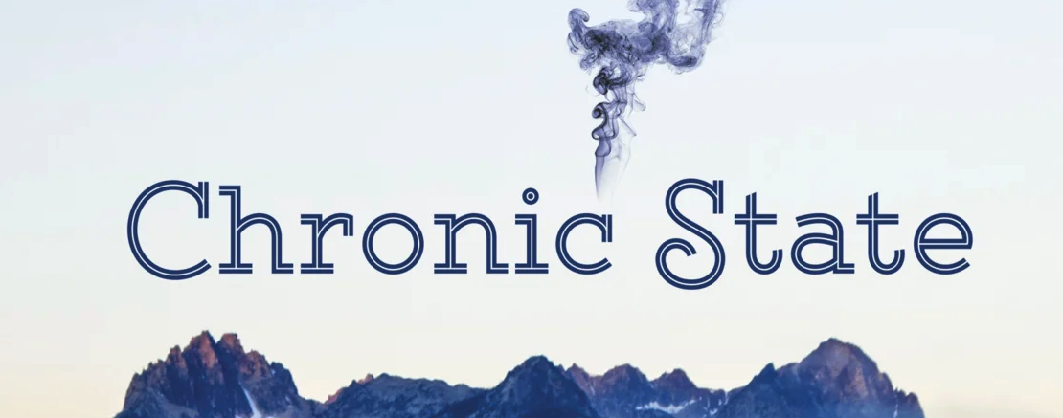 | A documentary which details the negative outcomes of the marijuana “experiment” in states like California, Colorado, Washington and Oregon.  How Marijuana Normalization Impacts Communities
Video Topics  - It’s a New Drug  - Marijuana and Taxes  - Marijuana and Youth  - The Marijuana Industry  - Stoned Driving  - Impact on Community Resources  - Marijuana as Medicine  - Marijuana and Mental Illness  - Marijuana Pregnancy & Babies  - Marijuana and Alcohol  - Marijuana and Homeless  - Marijuana’s Impact on the Environment  - Marijuana’s Impact on Neighborhoods  - Marijuana’s Impact on the Workforce  - Social Experiments or Human Lab Rats?  - Why Speak Out? |  |  | Ask Yourself…  What are things that stand out in your mind as important messages that will reach different demographics?  What can be done to limit youth access to marijuana where you live?  What concerns do you have about how marijuana might affect your family and community?  Do you think there should be age restrictions for those that attend marijuana events (i.e. The Cannabis Cup)?  How could / does marijuana effect the environment in your community?  Do you want marijuana dispensaries in your neighborhood?  Are you concerned with the effect 2nd hand smoke from marijuana might have on non-users (i.e. parks)?  How has legalization of marijuana impacted your community?
 |  |  | 5

“Number of drivers testing positive for marijuana involved in fatal car crashes has increased 66% since legalization occurred in Colorado.”  ~ Chelsey Clarke ~ Strategic Intelligence Analyst  “If you say ‘yes’ to legalization then you say ‘yes’ to more and future users. And these users are the youth of our community. The industry can’t survive unless they create more users.”  ~ Aubree Adams, Mother of A Youth in Recovery  “I’m in 80% of the state of Colorado’s schools, even in rural areas and I’ve yet to be in a school that’s gotten a dime (from marijuana taxes).”  ~ Lynn Riemer, President of ACT on Drugs  “Alcohol consumption has gone up each year since legalization.”  ~ Lynn Riemer, President of ACT on Drugs  “Levels of people getting caught with it are going down, which makes it look like the number of people using marijuana is decreasing when it’s not the case. It’s just significantly harder to detect when they use.”  ~ Matt Montgomery, Teacher & Former Law Enforcement |  |  | Drug Free Idaho partnered with Sidewayz Films and produced this one hour documentary detailing the negative outcomes of the marijuana “experiment” in California, Colorado, Washington and Oregon.  Impact on Schools, Workplace & Healthcare Industy  The film describes how marijuana is considered by educators in Colorado as the biggest problem in elementary, middle and high schools. Companies and doctors are leaving these communities, resulting in not enough jobs or adequate health care. Taxes raised on marijuana are not adding enough revenue into the state to cover the new problems.  Impact on Families & Neighborhoods  Grow houses are being set up in multiple neighboring homes in residential neighborhoods attracting outsiders, such as international drug cartels, who pose a risk to safety. A sheriff from the Emerald Triangle explains the difficulty of keeping up with crime and illegal grows.  We encourage everyone to research and educate themselves about how marijuana and other drugs impacts communities, youth, and public safety.  Documentary Info
4 |  |  | 1

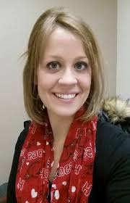  Film Contributor Bios  Lynn Riemer  Strategic Intelligence Analyst  Rocky Mountain High Intensity  Drug Trafficking Area (RMHIDTA)  The Rocky Mountain HIDTA's ultimate mission is to facilitate cooperation and coordination among federal, state and local drug enforcement efforts to enhance combating the drug trafficking problem locally, regionally and nationally.  Chelsey Clarke  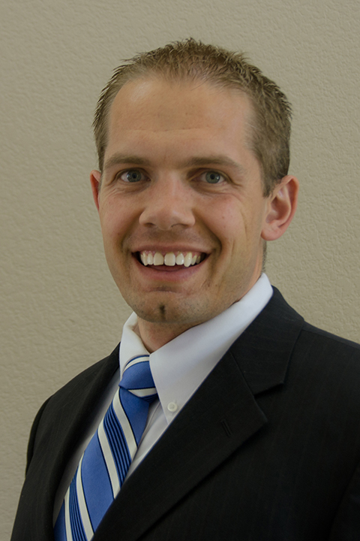  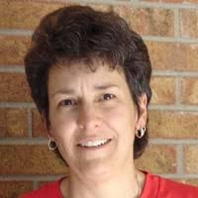  Brad Roberts MD  President of ACT on Drugs, Teacher  Former Forensic Chemist  An experienced chemist and prior member of the North Metro Drug Task Force in Colorado. Lynn has co-chaired the Drug Endangered Children program and speaks nationally about the dangers of drugs.  Emergency Medicine Specialist in Pueblo, CO  Dr. Roberts has seen the effect marijuana has had on his community first hand. He has been outspoken about the dangers and precautions that should be considered when deciding to use marijuana. |  |  | 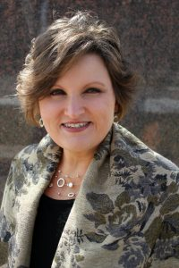  Sheriff Kirk Taylor  Chairman of the Board at National Drug and Alcohol Screening Association, President 5 Minutes of Courage  Jo McGuire serves on the board of directors for the Drug and Alcohol Testing Industry Association and co-chairs the Marijuana Education Committee.  Film Contributor Bios  Jo McGuire  Pueblo County Sheriff  Sheriff Taylor has spoken to local, state, and federal audiences for the National Sheriff’s Association and Western State Sheriff’s Association. The medical and recreational legalization of marijuana has profoundly affected his city and county. He has been featured on CBS 60 Minutes, and many other television programs.  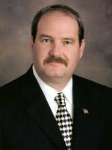  Libbt Stuyt MD  Medical Director, Circle Program at Colorado Mental Health Institute, Pueblo, CO  Dr. Stuyt is a board- certified Addiction Psychiatrist and Senior Instructor for University of Colorado HSC Department of Psychiatry. She is affiliated with the Colorado Mental Health Institute at Pueblo.
2 |  |  | 3

